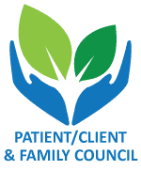

Offered by the Patient/Client & Family Council

A peer led non-profit organization offering services to clients and families accessing the Mental Health System.

## **Members**

## **Meeting**

On the third Tuesday of every month, the members of Our Place – Social Club meet at 3:00 pm to enjoy refreshments and baked goods while discussing club business.

Topics include what is going well, how we can make improvements, and which activities we would like to see on the club calendar for the next month.

*If you would like to attend, please drop by the club to begin your membership and sign up for the meeting.*

If you are interested, please contact the PCFC at

(705) 549-3181 Ext 2222