

**FAMILY PEER SUPPORT GROUP**

Providing support, education and hope to families and friends who care for loved ones affected by mental illness. We provide a safe, **confidential** environment for growth and healing by trained staff and volunteers with lived experience.

The meetings are held in Midland on the 2nd Tuesday of the month from 6:00 pm to 7:30 pm. Meetings are held at 334 King Street, Unit 2.

**FOR MORE INFORMATION PLEASE CONTACT**

**705-549-3181 ext. 3033**

**YOU NEVER NEED TO FEEL ALONE!**

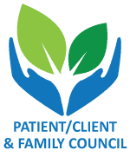

Offered by the Patient/Client & Family Council

A peer led non-profit organization offering services to clients and families accessing the Mental Health System.